Exp No: 27
BINARY SEMAPHORE IN SYSTEMC
AIM:
To implement and simulate a Binary Semaphore using SystemC for task synchronization
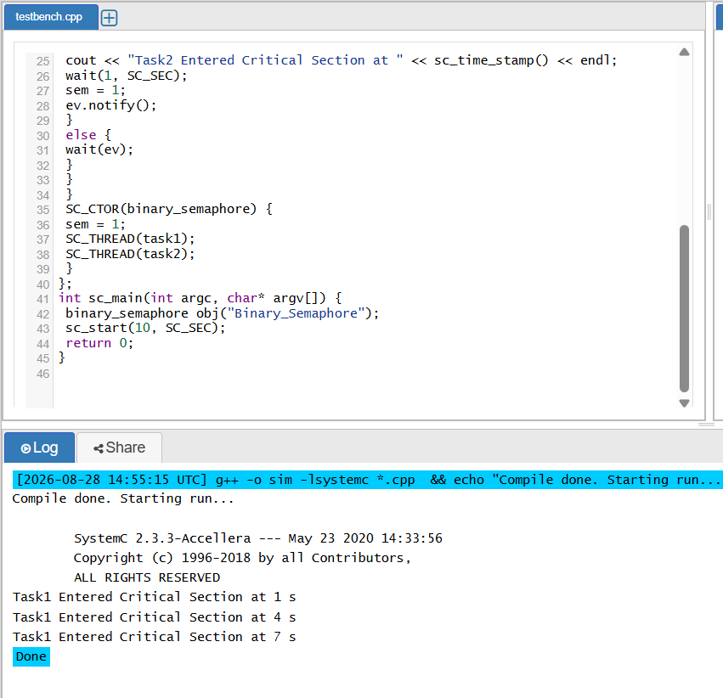
RESULT:
Thus the Binary Semaphore was created using SystemC and verified

